print

**Ideation phase**

Empathize & Discover

|  |  |
| --- | --- |
| Date | 13 OCTOBER 2022 |
| Team ID | PNT2022TMID47628 |
| Project Name | Rael- Time Communication System Powered by AI for Specially Abled |
| Maximum Marks | 4 Marks |

Empathy Map Canvas

Gain insight and understanding on solving customer problems.



Build empathy and keep your focus on the user by putting yourself in their shoes.

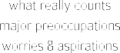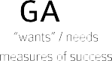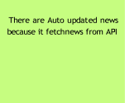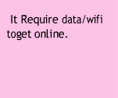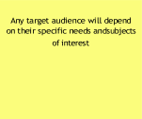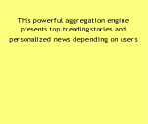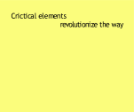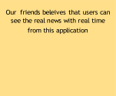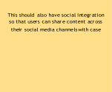

It track the latest

that has enabled

mobile apps to

users consume daily news

objectivity

Older audiences may not access

It acquires organic users in

manner

This application will show category wisenews

This will be

API and show itin the Application

The people

sites